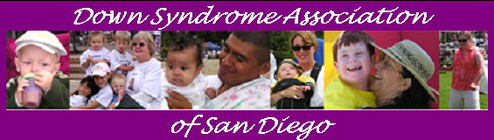
e-NEWS March 26, 2008

Dear Family and Friends,

Lifetime Television proudly premieres the Lifetime Original Movie Event, "The Memory Keeper's Daughter," starring film actors Dermot Mulroney ("My Best Friend's Wedding"), two-time Academy Award® and three-time Golden Globe® nominee Emily Watson ("Breaking the Waves") and Gretchen Mol ("The Notorious Bettie Paige"). Based on the runaway best-selling book by Kim Edwards of the same name, "The Memory Keeper's Daughter," premieres Saturday, April 12 at 9pm ET/PT on Lifetime Television. Encore airings will be presented on Sunday, April 13 and Monday, April 14 at 9pm (ET/PT) on each night.

In "The Memory Keeper's Daughter," a secret shapes the lives of two families over a quarter of a century, beginning in 1964. During a paralyzing winter storm, Dr. David Henry is forced to deliver his own twin babies. With his wife Norah under heavy sedation, he welcomes a healthy son, Paul, and a daughter, Phoebe who has Down syndrome. Hoping to spare his wife any heartache for having to care for a special needs child, David tells Norah their daughter died at birth and orders the nurse, Caroline, to place Phoebe in an institution. However, unable to abandon the newborn, the nurse secretly decides to raise Phoebe as her own in another city. This is just the beginning of a touching story.

To view media images of people with Down syndrome and to provide your input about the movie, visit http://www.mylifetime.com/on-tv/movies/memory-keepers-daughter .

Sue Moore
eNEWS Editor
----------------------------------------------------------------

In This eNEWS Issue You Will Find:
* SUPPORT GROUPS
* DSA FUNDRAISERS
* LEGISLATIVE ACTION ALERT
* RECREATION RESOURCE ROUNDUP
* RECREATION AND WELLNESS EXPO
* CHRIS BURKE & NDSS MAKE THE NEWS
* ECONOMIC STIMULUS PAYMENT INFORMATION
* BUDDY WALK 2008 UPDATE
----------------------------------------------------------------
DSA FUNDRAISERS:

Monday, April 14th – from 4:00pm - 10:00pm
Down Syndrome Association of San Diego is having a Fundraiser presented by The San Miguel Fire Department at Applebee’s in Rancho San Diego, located at 2508 Jamacha Road, El Cajon, CA 92019, (619) 670-7203. Applebee’s will donate 15% of the proceeds to The Down Syndrome Association of San Diego. You must present the flyer/coupon at the time of visit. Flyer/Coupons can be found at http://www.efrconline.org/admin/files/Applebees041408.doc
This is a 4 coupon per page flyer so each page can be cut to make 4 flyers. Please hand these out to as many people as you can that are interested in participating. The news media will be there, as well as fire department personnel. Let’s have a BIG turn out for this fun event!

Thursday, May 15th from 11:00am - 3:00pm
San Miguel Fire Fighters Local 1434 6th Annual Charity Golf Classic at Cottonwood at Rancho San Diego Golf Course. The 2008 featured charity is Down Syndrome Association of San Diego. (Proceeds shared equally with San Miguel Fire Fighter’s Charitable Causes Foundation and DSA San Diego.) For additional information, call Nick Johnson at (619) 654-3012 or e-mail 1434@smgfire.org. View Flyer at http://www.efrconline.org/admin/files/ACF283F.pdf or View Brochure at http://www.efrconline.org/admin/files/ACF283D.pdf

----------------------------------------------------------------
UPCOMING EVENTS:
For event details go to http://www.efrconline.org/calendar/maincal.cfm
By clicking on an event link you may view the event details.

Local:
4/2-4/08 After the Bell Rings – Inclusion Conference
4/10/08 SDUSD CACSE meeting - Clairemont
4/12/08 Involved Exceptional Parents' Day
4/12/08 Day of the Child
4/14/08 Applebee’s Dinner DSA Fundraiser
4/17/08 Parent Orientation to Special Education
4/17/08 Orientación a los Padres
4/19/08 Fiesta Educativa, Inc. Conference
5/15/08 Charity Golf Classic DSA Fundraiser

Regional:
4/18-19/08 DSA Orange County conference “Health Issues in Adolescents and Adults with Down syndrome”

----------------------------------------------------------------
UPCOMING EFRC SUPPORT GROUPS:
For details: http://www.efrconline.org/efrc.cfm?pid=Support_Groups

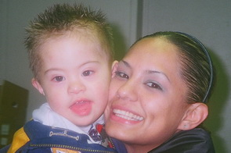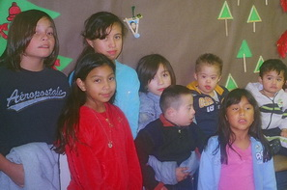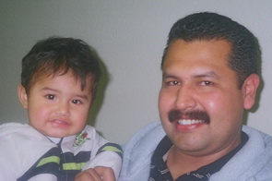

Join Us Tomorrow Night for > > > >
3/27/08 DSA/EFRC Central Grupo de Apoyo:
Asociación Síndrome de Down y Centro de Recursos para Familias Excepcionales lo invitan a asistir una seria de juntas para padres de niños (0-5 años de edad) que presentan Síndrome de Down. Hora: de 6:30 a 8:30pm. Lugar: Harold J Ballard Center, 2375 Congress Street, San Diego, CA 92110 (Old Town). Habrá una area de juegos supervisada para niños menores de 10 años. Reserve su lugar. Para hacer su reservación, llame al Centro de Recursos para Familias Excepcionales con Edna al 619-594-7407. Ver el volante a http://www.dsasdonline.org/admin/files/ACF8C0C.pdf

4/8/08 DSA/EFRC North County Support Group:
For parents of children birth to 5 years with Down syndrome. Meets monthly at the EFRC North Coastal office, 255 Pico Avenue Suite 101, San Marcos, CA 92069 (in the North County Regional Education Center) from 6:00pm - 7:30pm. No childcare provided, but parents are welcome to bring babies. For more information, please call (760)761-5553 or email tshortal@projects.sdsu.edu. View flyer at http://www.dsasdonline.org/admin/files/ACF8B1E.pdf or map at http://www.efrconline.org/efrc.cfm?pid=Locations

4/17/08 DSA/EFRC Central Support Group:
Support Group and informational meeting hosted by Down Syndrome Association and Exceptional Family Resource Center - for parents of children (birth-5) with Down syndrome. Meets monthly at the Harold J. Ballard Parent Center, 2375 Congress Street, San Diego 92110 (Old Town) from 6:30 - 8:30pm. Supervised play for children up to age 10 is available with reservation. Please call EFRC at (619) 594-7416. View flyer at http://www.dsasdonline.org/admin/files/Support Group DSA 20072008.pdf
----------------------------------------------------------------
INPUT NEEDED FROM THE COMMUNITY:

LEGISLATIVE ACTION ALERT - From the Arc of California
Legislators are looking for creative ways to continue to cut away at the
state's now $16 billion budget deficit and some think this approach
(below) might be viable. The Arc of CA is asking advocates to let their
legislators know what this marriage penalty would mean for couples with
one or more people with developmental disabilities:
Recently the Legislative Analyst has recommended reducing the SSI/SSP
grants to couples as a way to save additional state funds in their
proposed alternative budget. The LAO says, "we recommend reducing
SSI/SSP couples grants to 125 percent of the 2008 federal poverty
guideline. This results in General Fund savings of about $89.5 million
in 2008-09. Couples grants are currently at 131 percent of poverty,
while grants for individuals are at 100 percent of the 2008 federal
poverty guideline. Even with this reduction, SSI/SSP couples will remain
further above the poverty guideline than individuals.
This proposal would reduce the SSP grant for couples by $66, from $568
to $502, well above the current federal maintenance of effort
requirement ($396). This proposal does not result in any federal funds
loss, since it only affects the SSP portion of the grant. Couples would
continue to receive the federal COLA in January 2009, and would be
entitled to future federal and state COLAs when they are provided. The
SSP grant of $502, when combined with the federal SSI grant, would total
$1,458 per month for a couple.
(Analysis of the 2008-09 Budget Bill: Health and Social Services,
Supplemental Security Income/ State Supplementary Program (5180),
http://www.lao.ca.gov/analysis_2008/health_ss/hss_anl08012.%23zzee_link_2_1202952761

----------------------------------------------------------------

NDSS Celebrates World Down Syndrome Day by Ringing the NASDAQ Closing Bell



On Monday, March 17th the National Down Syndrome Society kicked off celebrations for World Down Syndrome Day, which was on March 21st, by ringing the closing bell at the NASDAQ in New York City. NDSS Goodwill Ambassador Chris Burke, and NDSS VP of Marketing and Communications Sarah Schleider spoke about the meaning of this special day around the world. Friends and members of NDSS participated in the closing bell ceremonies. More photos can be found at http://www1.ndss.org/index.php?option=com_content&task=view&id=2044&Itemid=233

----------------------------------------------------------------
RECREATION:

*Come One, Come All to the Opening Night of GB Productions’ Momsy’s Bad Boy on Friday, March 28th at 8:00pm at the North Park Vaudeville and Candy Shoppe. For information and reservations, call 619-220-8663 or visit northparkvaudeville.com. Tickets may be purchased at the door for $14. The show runs March 28 – April 20.
*Editor’s note: Our very own Rachel Goldbaum is in this show, so we are hoping for a BIG turnout on Opening Night. Please join us!

PROJECT CHAI – Creating Hope, Advocacy and Inclusion
A social and educational group for Jewish adults with developmental and physical disabilities and their families. The program provides participants with opportunities to meet others, develop supportive relationships and learn about Jewish culture and traditions. The first event will be sponsored by JFS on March 26th at 6:30 p.m. at the Turk Center, 8804 Balboa Avenue. Food and Drink will be provided. Contact Albert Schafer at (858) 637-3229 or alberts@jfssd.org

East County CHILDREN'S DISABILITY COUNCIL Sponsored by Center for Social Advocacy presents their 7th Annual RECREATION RESOURCE ROUNDUP on Thursday, April 17, 2008 from 10:00am-12:30pm at the El Cajon Community Center, 195 East Douglas Avenue (by the El Cajon Library). Families, caregivers and community partners are invited to learn about recreation opportunities, sports and arts programs, and camps, for children/adults with all types of disabilities. Many programs, recreation departments, and camps will have people on hand to give you personalized information. Some programs and camps fill fast, so you will be able to apply early.
***A $ 3.00 admission donation will be appreciated by our volunteer organization. Lunch provided. Free Recreational Resources Guide! Door Prizes. Recreational Scholarships are available. Get your application form at Round-Up! Call Ahead If You Need Childcare. For more information call Janet Light 619-465-2288 or e-mail Janet at Asecsess@cox.net

4/02/08 Recreation and Wellness Expo for Children & Young Adults with Special Needs. Featuring Demonstrations, Hands-on Activities, Physical Fitness Opportunities, Healthcare Information, Client Advocacy & Referral, Equipment Vendors, Give Aways and much more!! Location: California State University San Marcos Clarke Field House/University Student Union, 760.432.2296. Parking is FREE! Drop off area available. For more information, contact Dr. Kara Witzke at 760-750-7355 or Dr. Eliza Bigham 760-750-8092 or www.RecExpoNorth.org.

Xcite Steps is thrilled to introduce CAMP STEPS for the upcoming summer of 2008. Camp Steps is a fun beach & community activity camp available to kids, teens and adults with developmental or cognitive challenges. The camp is every week of the summer, M-F starting June 16th and concluding on August 29th. For more information contact Matt Winkley at 858 722-1948 or email mwinkley@exciteway.com. Registration Deadline is May 17th with a “Get to know us” party at Fletchers Cove. Bring your child, drop off your deposit, and meet the staff and the other campers. The brochure can be found at http://www.efrconline.org/admin/files/Camp%20Steps%202008.pdf. The application can be found at http://www.efrconline.org/admin/files/Camp%20Steps%20App.pdf.

----------------------------------------------------------------

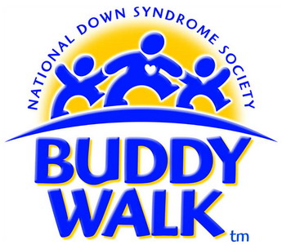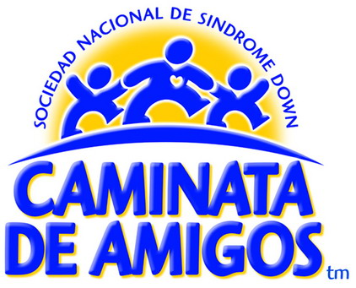

SAVE THE DATE!
The 2008 San Diego Buddy Walk Date is
Saturday, October 18th in Balboa Park.

¡APARTE LA FECHA!
El 2008 Caminata De Amigos de San Diego es
Sabado, 18 de Octubre en el Parque Balboa.

----------------------------------------------------------------
Economic Stimulus Payment

The IRS is mailing Package 1040A-3 to every Social Security [SSA] and Veteran's Administration [VA] beneficiary in the nation. This package tells individuals with benefits how to fill out an abbreviated version of Form 1040A to request a payment. View pdf file at http://www.efrconline.org/admin/files/stimulus%20package_1040a-3.pdf. Individuals can file on-line at www.irs.gov. Many individuals with disabilities who have low earnings and/or who only receive benefits such as VA or SSA are not required to file annual tax returns. However, to receive the $300 economic stimulus payment available to people with benefits or low income the person MUST FILE the abbreviated 1040A for tax year 2007. The IRS encourages everyone to file as early as possible. Tax returns for a stimulus payment must be filed by October 15, 2008.

Some points to remember: individuals claimed as dependents cannot file for their own stimulus payments. Individuals who only receive Supplemental Security Income (SSI) are not eligible. The Medicaid and SSI Programs will not count the stimulus payment as income towards these benefits in the month of receipt. The money from the stimulus payment will become a countable resource if it is not spent before the third month following the month of receipt. Click on the Stimulus Payment at www.irs.gov or for other details, visit http://www.efrconline.org/admin/files/Economic%20Stimulus%20Info%20.doc

Información sobre los Pagos de Estímulo Económico

Información Personas Quienes Reciben Beneficios del Seguro Social y Ciertos Beneficios de Veteranos

----------------------------------------------------------------
INSPIRATION:

“Only as high as I reach can I grow,
Only as far as I seek can I go,
Only as deep as I look can I see,
Only as much as I dream can I be.”
“Solo tan alto a donde alcanzo puedo crecer,
solo tan lejos a donde exploro puedo llegar,
solo en la profundidad en la que miro puedo ver,
solo en la medida en la que sueño puedo ser.”
- Karen Ravn

-----------------------------------------------------------
If you enjoyed this eNEWS, please consider forwarding it to
friends and family to spread the word of upcoming workshops
and events, links to new sites and up-to-date information
about the special needs community.

This e-NEWS has been brought to you by
Down Syndrome Association of San Diego.
If you have comments or would like to
Unsubscribe, please contact us at
info@dsasdonline.org. Visit dsasdonline.org.
March 26, 2008

Down Syndrome Association of San Diego does not promote or recommend any therapy, treatment, institution, etc. and does not espouse any particular political, educational or religious views. Inclusion of information or resources does not necessarily imply promotion or recommendation by DSA. Content is provided for informational purposes only.

