Down Syndrome Association
of San Diego
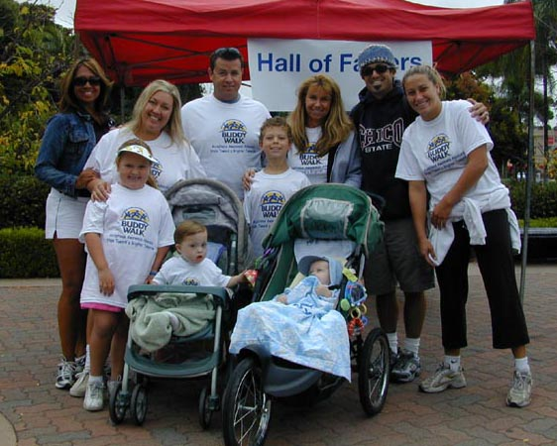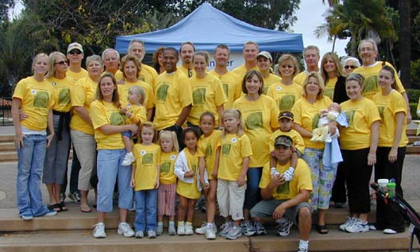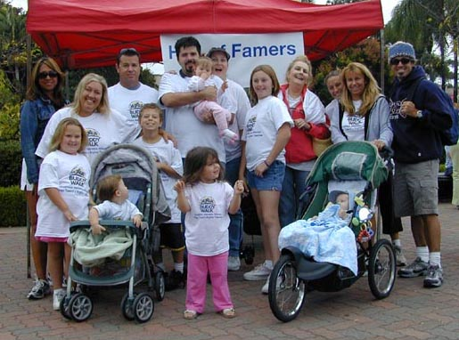
e-NEWS June 29, 2006

Dear Family and Friends,

Our 22nd Annual Family Social will be held on July 16th at Carmel Mountain Ranch Sabre Springs Recreation Center. Please join us for a fun family event. To view the flyer, go to http://www.dsasdonline.org/admin/files/DSASummer%20Social%2006.doc
You may register online, by mail or by fax. Please RSVP right away!

This year’s National Down Syndrome Congress Annual Convention is shaping up to be one of the best ever – but it won’t be the same without you! Go to http://www.dsasdonline.org/admin/files/NDSC%20Convention%20News06.pdf to learn more about our latest confirmed speakers and topics and about other events planned for this year’s “family reunion”!
The State Council on Developmental Disabilities needs input from all constituents, including YOU!
The State Council on Developmental Disabilities is conducting the second public meeting to gather community input to include in a draft State Plan for 2007 – 2011 on Saturday July 8, 2006 12:30 – 2:30 PM following the San Diego People First Meeting in Balboa Park. A member of the State Council Staff will be in attendance to listen to your ideas, recommendations and priorities.

Where: Balboa Park Club, Santa Fe Room, 2150 Pan American Road West (Next to the Puppet Theater/Recital Hall in Balboa Park)

To view the Draft Plan, go to
http://www.scdd.ca.gov/our_plan/20072011/Public%20Review%20Draft%202007%20Plan.pdf
or by calling 1-866-802-0514. The comment period ends July 17. Key
priority areas cited in the draft plan include: cost of living, aging,
health care, diversity and complex service delivery.

The Mission: The Council advocates, promotes and implements policies and practices that achieve self-determination, independence, productivity and inclusion in all aspects of community life for Californians with developmental disabilities and their families.

The State Council receives federal funds and advises the government about important issues for Californians with developmental disabilities and their families. It is important for people with developmental disabilities, family members, friends and concerned individuals to review the draft plan and make recommendations to ensure that their needs are adequately addressed. At least 70 percent of all the federal money the Council receives must be spent working on issues identified in the State Plan.

The review and comment period is from June 1 to July 17, 2006. People can tell the Council their thoughts about the Plan by coming to a State Plan hearing, or by sending a letter, fax or email. Many of the Area Boards will also discuss the State Plan at their June or July Area Board meetings.

A self-advocate summary and survey are on the Council website at http://www.scdd.ca.gov/our_plan/2007-2011/Self%20Advocate%20Summary%20Draft%202007%20Plan.pdf , or call the Council Office (toll-free) at 1-866-802-0514. On July 18, the Council will review what people said about the Draft Plan and vote on the final Plan that will be submitted to the Federal Government in August. In the fall of 2006, the Federal Government will tell the Council if the Plan was approved. Let’s raise the bar and improve the quality of life for all Californians by participating in the development of the State Plan!

----------------------------------------------------------------
CALLING ALL DONORS:
As you know, our family summer social is just around the corner; and that means it is time to help us gather up great prizes and donations for this worthwhile and fun event. DSASD is requesting your support in sponsoring or donating to the Annual Family Summer Social, on July 16, 2006, at the Carmel Mountain Ranch Sabre Springs Recreation Center. We are asking for cash donations, services and/or merchandise to assist with associated costs of the Family Social. Donations will be acknowledged on publicity materials associated with the event including website, e-news and signage. Please send all donations to:
Rachel Goldbaum
ATTN: DSA Summer Social
8435 Cliffridge Lane, La Jolla, CA 92037

THANK YOU FOR YOUR SUPPORT!
----------------------------------------------------------------
NDSS NEWS:
Celebrate the Buddy Walk's 11th anniversary by entering the Times Square Video Contest. The video, which showcases the community contributions of individuals with Down syndrome, will air on the Panasonic Astrovision screen in Times Square on September 17 at 10:30 a.m. The New York City Buddy Walk will follow the video at the Great Hill in Central Park.
Each year, NDSS receives thousands of photo submissions for the Times Square Video Contest. Because the Buddy Walk promotes acceptance and inclusion of individuals with Down syndrome, the winning photographs feature children, teens and adults with Down syndrome working, playing and learning with friends and family. Please limit photos to no more than three per individual with Down syndrome.
For more information, or to submit a photo, go to http://www.buddywalk.org/index.cfm/fuseaction/tsv.contentItem/contentID/839fc4d2-408f-4fd0-b7c1-bfdfef471cf7. The deadline for submitting photos is July 21, 2006. To view the 2005 Times Square Video, go to http://www.buddywalk.org/index.cfm/fuseaction/tsv.contentItem/contentID/09404688-78f0-475e-848a-242168cdf319.
NDSS will notify you ONLY if we accept your photograph for the video, and we are unable to return any photos. For further questions about the contest, contact Danielle Reddy at 800-221-4602 or dreddy@ndss.org.
----------------------------------------------------------------
UPCOMING EVENTS:
By clicking on an event link you may view the event details.

Local:
6/29/06 Accessibility Overview – Interwork institute.
7/08/06 People First/ State Plan Public Hearing – Balboa Park.
7/08/06 FasTracKids Open House - Tierrasanta
7/13-15/06 Summer Leadership Institute - Cal State San Marcos.
7/14/06 Workforce Development Training – San Diego.

7/16/06 22nd Annual DSASD Family Social from 1:00 - 4:00pm at Carmel Mountain Ranch Sabre Springs Recreation Center, located at 10152 Rancho Carmel Drive, San Diego 92128. Come to a good old fashioned picnic with great food, kids activities, Susie's Dance Party, and opportunity drawings for great prizes. Please RSVP no later than July 10th. For more information, View flyer or call 619-276-4494.

7/18-22/06 Higher Education and Disability conference
7/19/06 Padres Celebrate Disability Awareness Day – Petco Park.
7/23/06 TOPSoccer Clinic - La Jolla

Regional:
7/21-23/06 34th Annual National Down Syndrome Congress National Convention - Georgia.

9/13-15/06 First National Conference for Mentoring Youth with Disabilities - Boston.

----------------------------------------------------------------
UPCOMING SUPPORT GROUPS:
For details http://www.dsasdonline.org/efrc.cfm?pid=Support_Groups

6/29/2006 Grupo de Apoyo - para padres de niños (0-5 años de edad) que presentan Síndrome de Down. Old Town. Also on July 21, 2006.
----------------------------------------------------------------
OPPORTUNITIES FOR YOUTH:
INTERNATIONAL JURIED FINE ARTS & CRAFTS EXHIBITION
Open to artists with physical, cognitive, due to brain injury, visual and hearing disabilities. Only work executed after the onset of disability or injury will be considered. Open to all media, including Works on Paper, Paintings, Sculpture, Jewelry, Photography, Pottery, Fiber arts, and Other crafts. Over $5,000 in prizes. No submission fee. For complete prospectus and submission form please send SASE to: Shakerra Grays, Art Ability, Bryn Mawr Rehab Hospital, 414 Paoli Pike, Malvern PA 19355 OR grayss@mlhs.org
ART EXHIBITION FOR YOUTH WITH DISABILITIES SEEKS ENTRIES
VSA Arts (supported by Volkswagen of America) is hosting a national juried art exhibit, "Destination Anywhere," for youth ages 16-25 who have physical, cognitive, or mental disabilities. Deadline for entries is July 14. For more information and guidelines, visit the VSA Arts website.
http://www.vsarts.org/prebuilt/showcase/gallery/exhibits/vw/2006/

NATIONAL GARDENING ASSOCIATION, HOME DEPOT OFFERING GRANTS FOR YOUNG GARDEN PROJECTS
Organizations wanting to engage children with disabilities in garden projects in 2007 may apply for Youth Garden Grants through the National Gardening Assn. and Home Depot. Treatment facilities, camps, schools, community centers, clubs, youth groups and intergenerational groups throughout the nation are eligible to apply-as long as groups include at least 15 children between the ages of 3 - 18. Applicants need to demonstrate a child-centered plan that emphasizes children and youth working in an outdoor garden. Winning programs will receive educational materials from NGA and a gift card for use at Home Depot. For more information go to http://www.kidsgardening.com/YGG.asp
----------------------------------------------------------------
INDEPENDENT LIVING ISSUES:
Read about the Department of Transportation’s addition of a requirement for transit agencies to make reasonable modifications of policies, practices, and procedures. Go to http://www.efrconline.org/admin/files/DREDF%20alert%20on%20Dept%20of%20Transportation.doc
----------------------------------------------------------------
REFERENCE POINTS:
New Edition of "Impact" Focuses on Parenting Teens and Young Adult
with Disabilities from June 26, 2006
The passage from childhood to adulthood is a passage for families as well
as individuals. As young people with disabilities move from their teen to
adult years, they and their families experience many growing pains in
common with all families at that stage of life. In addition, there are often
milestones, questions, concerns, needs, and challenges unique to
individuals with disabilities and their families. In this issue of Impact we
explore strategies for families of teens and young adults with disabilities to
consider in navigating the transition years with their young person, and
share stories of those who are in the middle of it or have come out the
other side.
For the generation of young people with disabilities reaching adulthood
today there are ever-expanding opportunities to pursue adult lives that
reflect their goals, dreams, ambitions, values, and life visions. And there
are still barriers to that achievement--limitations in services, supports,
resources, and options. It's our hope that the articles in this Impact will
provide a glimpse of what is possible, offer useful ideas for moving past
some of the limitations that get in the way, and support families, teens,
and young adults in dreaming big and realizing those dreams. Links to the
issue can be found at http://ici.umn.edu/products/impact/192/default.html
or http://ici.umn.edu/products/impact/192/192.pdf

The National Center on Secondary Education and Transition is funded
by and is a partner with the U.S. Department of Education, Office of
Special Education Programs, cooperative agreement # H326J000005.
The TATRA Project is funded by the Rehabilitation Services Administration.
Visit http://www.ncset.org.
----------------------------------------------------------------
RESOURCES:
The US Department of Justice has added additional content to their
Video Gallery Section of the WWW.ADA.GOV web site. This new piece
is an eight part series titled "Police Response to People with Disabilities"
and is designed to be used in roll-call training. It addresses law
enforcement situations involving people who have mobility disabilities,
mental illnesses, mental retardation, epilepsy or seizure disorders,
speech disabilities, deafness or hard of hearing , and blindness or low
vision. The segments can be viewed at http://www.usdoj.gov/crt/ada/videogallery.htm#Anchor-Dial-47492. This
information was provided by the Great Lakes ADA and Accessible IT
Center (www.adagreatlakes.org)
----------------------------------------------------------------
RECREATION:

The National Sports Center for the Disabled Soccer Development League is scheduled to begin in just a few weeks. Register NOW!!!!! The NSCD is partnering with Alliance Soccer Club, Chula Vista Rangers and Poway/PQ, to create a soccer league for children with physical Disabilities.Contact Dana at (619) 482-6177 or e-mail dschoenwetter@nscd.org. View Details.
Challenger Baseball Leagues - Little League Challenger Division games
provide opportunities for children with disabilities (5-17) to play ball with as
much or as little assitance from typical peer buddies as needed. Players in the Challenger Division are not required to live in the city where their team plays, as are other Little League players.
Escondido. Call Leanna Long at 760 233-0202 for information.
Oceanside: Call Shawn Homan at 760 945-2398 or Trish Shortal at
760 433-7148.
San Diego -- University City, Coronado and Clairemont. Call Glen Castan at 858 457-1245 for details. The University City Little League website is www.ucll.org.
AYSO (American Youth Soccer Organization) Region 152 has several VIP soccer teams for children with special needs. The teams are located in Tierrasanta, Chula Vista, Bonita, El Cajon, and Santee. Children do not have to be living in the boundaries of these areas to play - in other words, the teams accept children from all areas. Registration begins in June and the season starts in September. Contact Mary Waltari at 858-566-2040 or mwaltari@san.rr.com.

Carlsbad Lightning Soccer Club season starts in Sept. on Saturdays.
Contact Cori Durfey at 760-632-0887 or visit www.lightningsoccerclub.com.
Adapted Aquatics at Ivey Ranch Park Association Brooks Street Pool in
Oceanside on Saturdays - June 24 thru July 22. Call 760-722-4839

TOPSoccer - Click here to View Flyer. For more information, email
cysacoachrick@aol.com or TOPSoccerSD@yahoo.com or call Rick Flores
at 760-519-4233.

Are you interested in joining a playgroup with your child? Shellie is
the mom of a 2 year old with Down syndrome who lives on a farm in
El Cajon and wants to start up a playgroup. If you are interested, please
call her at 619-454-4417.

-----------------------------------------------------------
If you enjoyed this eNEWS, please consider forwarding it to
friends and family to spread the word of upcoming workshops
and events, links to new sites and up-to-date information
about the special needs community.

This e-NEWS has been brought to you by
Down Syndrome Association of San Diego.
If you have comments or would like to
Unsubscribe, please contact us at
info@dsasdonline.org.
For more information, visit our website
http://www.dsasdonline.org.
June 29, 2006

