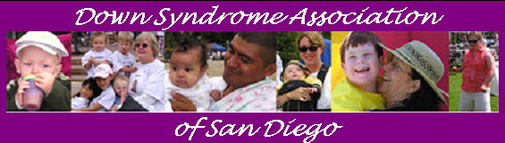
e-NEWS March 6, 2007

Dear Family and Friends,

Please SAVE THE DATE for our upcoming MOM’S NIGHT OUT on Saturday, March 31st at the Loews Coronado Bay Resort. We will have dinner and special over night room rates. More details will follow. If you would like more information, please call 619-276-4494 or email us at dsasd@projects.sdsu.edu .

Another date you will want to save on your calendar is Saturday, May 5th. We will be having our 2nd Annual Dinner Dance and Silent Auction – “Follow Your Dreams” at the Loews Coronado Bay Resort. More details to follow in upcoming eNEWS!!!

The bowling event was a great success. If you have any photos of the event and would like to add them to our online photo album, please send them to us. To view photos already submitted, go to http://www.dsasdonline.org/dsasd.cfm?pid=photo_album_select

Since we will not be hosting an egg hunt this year, we wanted to let you know about this event. The 34th Annual Easter Egg Hunt and Family Luncheon will be presented by Easter Seals and the Hilton San Diego Resort. Children with special needs and their families are invited to the
Hilton San Diego Resort located at 1775 East Mission Bay Dr. Egg Hunt on April 7th from 11:30am - 1:30pm. Luncheon and Entertainment will be provided. RESERVATIONS ARE A MUST - RSVP to Tracy Gordon at 858-592-7837 or 858-357-3002 or email at gordonfamily4@sbcglobal.net.

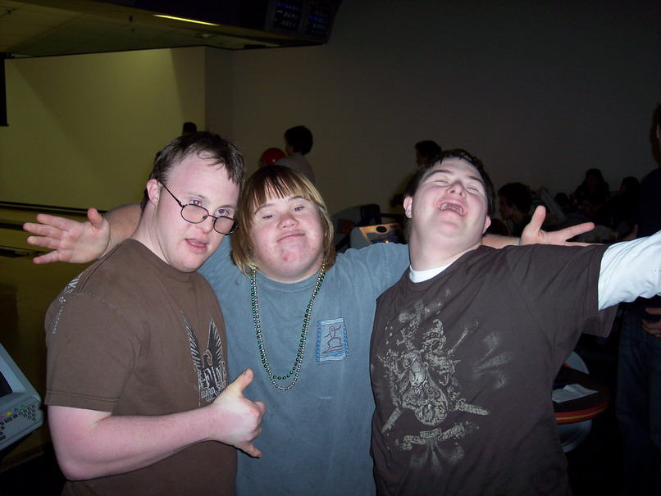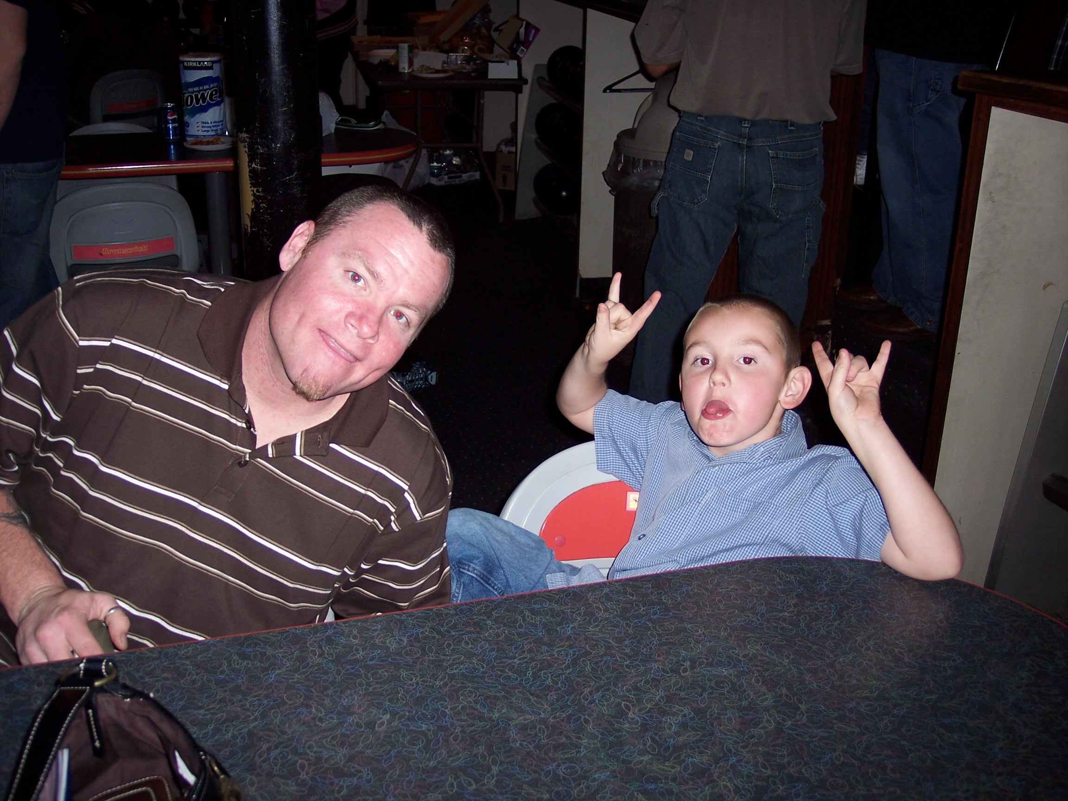

Remember to register for Involved Exceptional Parent's Day at the Handlery Hotel in Mission Valley, San Diego. The Keynote speaker is Kathie Snow. For more information, visit www.iepday.org To register, go to http://www.efrconline.org/admin/files/IEP day07 registration.pdf
and for Spanish, go to http://www.efrconline.org/admin/files/IEP day 2007 span reg.pdf San Diego Unified School District is offering scholarships. For details, please contact Lora Keller at (619) 725-8186 or lkeller@sandi.net

----------------------------------------------------------------
UPCOMING EVENTS:
By clicking on an event link you may view the event details or go to http://www.efrconline.org/calendar/maincal.cfm for all events.

Local:
3/20/07 School Problems Workshop Part I - Clairemont
3/27/07 School Problems Workshop Part II - Clairemont
3/28/07 Disability Awareness – Mission Valley
3/30/07 Ability Awareness in Action training
3/31/07 Involved Exceptional Parent's Day - Mission Valley
3/31/07 IEP Boot Camp for Military families - SD Naval Hospital
4/13/07 San Diego's People First Self-Advocacy conference
4/14/07 Fiesta Educativa Congreso Anual #11
4/18/07 National Conference on Inclusion – Kona Kai Resort

National:
6/13–15/07 9th Annual International Fatherhood Conference - Georgia

6/13-15/07 Bridges to Employment Conference – Miami, FL.

----------------------------------------------------------------
UPCOMING SUPPORT GROUPS:
For details: http://www.efrconline.org/efrc.cfm?pid=Support_Groups

3/13/07 DSA/EFRC North County Support Group:
For parents of children birth to 5years with Down syndrome.
Meets monthly at the EFRC North Coastal office, 380 Mulberry Drive Suite A, San Marcos 92069 from 6:00pm - 7:30pm. No childcare provided, but parents are welcome to bring babies. For more information, please call 760-510-3994 or email tshortal@projects.sdsu.edu. View flyer at
http://www.efrconline.org/admin/files/Support%20Group%20DSA%20San%20Marcos%202007.pdf

3/15/07 DSA/EFRC Central Support Group:
For parents of children birth to five years with Down syndrome.
Meets monthly at the Harold J. Ballard Parent Center, 2375 Congress Street, San Diego 92110 (Old Town) from 6:30 - 8:30pm. Supervised play for children up to age 10 is available with reservation. Please call EFRC at (619) 594-7416. View flyer at http://www.efrconline.org/admin/files/Support%20Group%20DSA%20English%202007.pdf

3/29/07 DSA/EFRC Central Grupo de Apoyo:
Asociación Síndrome de Down y Centro de Recursos para Familias Excepcionales lo invitan a asistir una seria de juntas para padres de niños (0-5 años de edad) que presentan Síndrome de Down
Hora: de 6:30 a 8:30pm. Lugar: Harold J Ballard Center, 2375 Congress Street, San Diego, CA 92110 (Old Town). Habrá una area de juegos supervisada para niños menores de 10 años. Reserve su lugar. Para hacer su reservación, llame al Centro de Recursos para Familias Excepcionales con Edna al 619-594-7407. Ver el Volante a http://www.efrconline.org/admin/files/Support%20Group%20DSA%20spanish%202007.pdf

----------------------------------------------------------------
RECREATION:

3/9/07 Assist in developing your child's language skills - FasTracKids (FasTrack Signing) and Java Mama will be offering a storytime for children and their parents. Signing storytime is a fun way to communicate with your child, by using your hands. Sign language can assist you in developing your child's language skills. Learn new American Sign Language (ASL) signs or practice ones you know through the magic of storytime at Java Mama in La Mesa at 3:00pm. For more information, go to www.javamama.com and www.sdenrichmentplace.com

3/25/07 Best Buddy Dance in Balboa Park.

4/7/07 Easter Seals Egg Hunt at Mission Bay

4/7/07 3rd Annual San Diego People First fundraiser “A Day in the Country” - Cajun band, hay rides, petting soo, face painting, egg hunt, raffles & more in Jamul. Adults - $25 and Children 12 & under - $10. Must RSVP by March 26. For more information, call 619.468.3120.

Check out our online calendar for some fun family events coming up in the community. Go to http://www.efrconline.org/calendar/maincal.cfm

NEW MOVIE OPENS MARCH 16th - My Brother" a movie starring 2 young men with developmental disabilities. The producer encourages everyone to go on opening weekend to ensure a long run for the movie. Please take the time and have a look at their website, www.mybrotherthemovie.com, and www.myspace.com/mybrotherthemovie. Check out the trailer and behind the scenes documentary for the movie. And more importantly, spread the word and join the thousands of people that have been amazed and touched by Chris Scott and Donovan Jennings. Neither Chris nor Donovan had ever acted before My Brother. But they have more in common - Chris and Donovan both have Downs Syndrome. They are the first African Americans with a developmental disability ever to play lead roles in a feature motion picture.
----------------------------------------------------------------
RESEARCH IN THE NEWS:
News from DSALA: News article below from Mercury News about a research report published in the Nature Neuroscience journal – 2/25/07
Stanford researchers say drug improves mice with Down syndrome
IT'S TOO EARLY TO TELL IF THE DRUG WILL BE SUCCESSFUL IN PEOPLE
In a study that could hold promise for children with Down Syndrome,
Stanford University researchers have found that a long-discredited
drug can improve the mental abilities of mice with the genetic
disorder, which causes mental retardation in humans.
The mice were better able to navigate mazes and recognize new objects
after receiving the drug, and the gains continued for months after
treatment stopped. The researchers ultimately hope to test the drug,
known as pentylenetetrazole or PTZ, in people with Down syndrome.
``It's a very exciting piece of work,'' said David Patterson, a Down
syndrome researcher at the University of Denver who was not involved
in the study. ``This is really the first time that I've seen such a
striking effect in terms of reversing the memory and learning
difficulties the mice have.''
Both Patterson and the Stanford researchers caution, however, that the
research is preliminary and it is too early to tell if the drug will
be successful in people. Although PTZ was once used as a heart
stimulant, it was taken off the market and now is used only in
research. The process of doing further tests and getting government
approval to use it as a Down syndrome treatment could take more than a
decade.
A genetic disorder caused by an extra copy of the 21st chromosome,
Down syndrome occurs in one of every 733 live births. More than
350,000 Americans have the condition, according to the National Down
Syndrome Society. The disorder typically causes mild to moderate
mental retardation and can increase the risk for Alzheimer's disease,
leukemia and congenital heart defects.
Because people with Down syndrome are now living much longer, with a
typical life expectancy of 56 years, researchers increasingly are
studying ways to improve their quality of life. Some studies have
examined whether Alzheimer's drugs could improve their mental
abilities, with little success, said Craig Garner, co-director of
Stanford's Down Syndrome Research Center and one of the authors of the new study.
In the study, published online today by the journal Nature
Neuroscience, mice genetically engineered to display the symptoms of
Down Syndrome were fed 17 daily doses of milk containing PTZ. After
treatment, they performed as well as ``normal'' mice in running mazes
and recognizing objects for up to two months.
It took some time for the drug to work -- an effect seen with many
psychiatric drugs, including antidepressants. The mice also received
two other compounds similar to PTZ, which worked about as well. The
``normal'' mice did not see any cognitive benefit from the compounds.
Stanford researchers believe that PTZ and the other compounds may work because they block a neurotransmitter that slows brain function. That
neurotransmitter is believed to work too well in Down syndrome
patients, hampering learning and memory.
Garner said these compounds help ``release the brakes'' on chemical
impulses in the brain that drive cognition. ``If you drive the car
with the brake on, you don't get anywhere,'' he said.
The Stanford researchers want to continue studying PTZ, rather than
the other compounds used in the study, because it was once approved
for use in humans.
The drug pentylenetetrazole was used as a heart stimulant and has been
used experimentally to study seizures. When used in high doses, it can
cause convulsions. The U.S. Food and Drug Administration removed the
drug from the market in 1982 because it was not effective in treating
disease and could be harmful, Garner said. But Garner believes the
drug can be safely used in very small doses.
``We think we're slowly being able to understand what's causing
reduced cognitive ability in people with Down syndrome,'' he said, and
there are new approaches and strategies that could improve their
quality of life. But, he added, ``This is not a cure. We're not making
a kid with Down syndrome normal. There are limits to what medicine can
do.''
Contact Barbara Feder Ostrov at bfeder@mercurynews.com
----------------------------------------------------------------
OPPORTUNITIES:

2007 Logo Design contest for this year’s Technical Assistance Institute by the Administration on Developmental Disabilities Youth Information and Training Resource Centers. Are you a young person with a disability who enjoys creating and expressing yourself through art? For contest details, go to http://www.efrconline.org/admin/files/Logo%20Design%20Contest%20Entry.doc

Project LEADERS (Learning Educating Advocating Directing Efforts for Responsible Self-Determination) - Looking for individuals with developmental disabilities who are interested in learning about Self-Directed Services. Sign up deadline is March 16th. Services will begin April 2nd. For more information, contact Marjorie Olney at 619.594.6883, olney@interwork.sdsu.edu or Janice Goforth at 619.594.1758, jgoforth@interwork.sdsu.edu

----------------------------------------------------------------
NEW RESOURCES:

Tax tips for family caregivers
Did you know that as a family caregiver, you may be entitled to deductions or credits that can help take some of the sting out of tax season? Here are some things to think about to maximize your deductions.
Medical Expenses Deductions – for this to qualify as a medical expense you must have spent money to alleviate or prevent a physical or mental defect or illness which can include medical insurance premiums (unless pre-tax); prescription medicines; doctors’ bills; hospital fees; travel to and from medical appointments at 18 cents/mile.
- Special Expenses – you can claim oxygen and the equipment; special schools or homes; artificial limbs; false teeth; eyeglasses; wheelchairs and repairs; crutches; guide dogs; etc.
- Nursing home care – only the medical expenses incurred in a nursing home.
- Nursing, Therapeutic, and/or aide services
For more tax tip information please visit http://thefamilycaregiver.org/caregiving_resources/takecare_newsleter.cfm and click on the Winter 2007 Take Care newsletter.

----------------------------------------------------------------
INSPIRATION FOR THE WEEK:

“We are new every day.”
- Irene Claremont de Castillego

-----------------------------------------------------------
If you enjoyed this eNEWS, please consider forwarding it to
friends and family to spread the word of upcoming workshops
and events, links to new sites and up-to-date information
about the special needs community. Click here to
FORWARD TO A FRIEND

This e-NEWS has been brought to you by
Down Syndrome Association of San Diego.
If you have comments or would like to
Unsubscribe, please contact us at
info@dsasdonline.org
For more information, visit our website
http://www.dsasdonline.org
March 6, 2007

Down Syndrome Association of San Diego does not promote or recommend any therapy, treatment, institution, etc. and does not espouse any particular political, educational or religious views. Inclusion of information or resources does not necessarily imply promotion or recommendation by DSA of San Diego. Content is provided for informational purposes only.

